**Student Number:** C16310846 **Group Number:** DT2112B5

**Task Summary**

In this assignment I worked on the tables USERUSAGE and STORES. This meant granting myself access to these tables when I started. I then began populating the tables with data. In part 3 I started creating update statements to update the data in the tables. For the next section I used select statements with conditions to complete the projection, selection and sorting element of the assignment. I then used select statement with order by to make use of non-aggregate functions for the following question. Then to test for nulls and not null in my code I used select statements with the where clause as well as null and not null to check the contents of the tables. Then I used select statements with group by and having clause to complete the aggregation section of the assignment. Finally I successfully implemented intersect, minus and union into my tables. I was unable to finish the rest of the questions in the assignment.

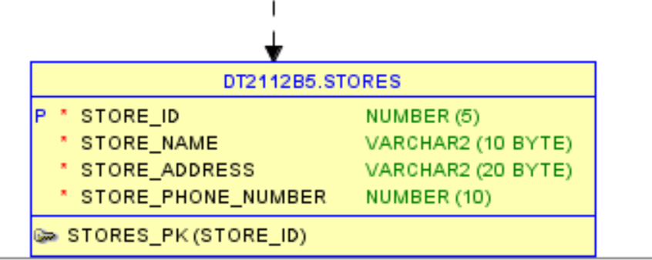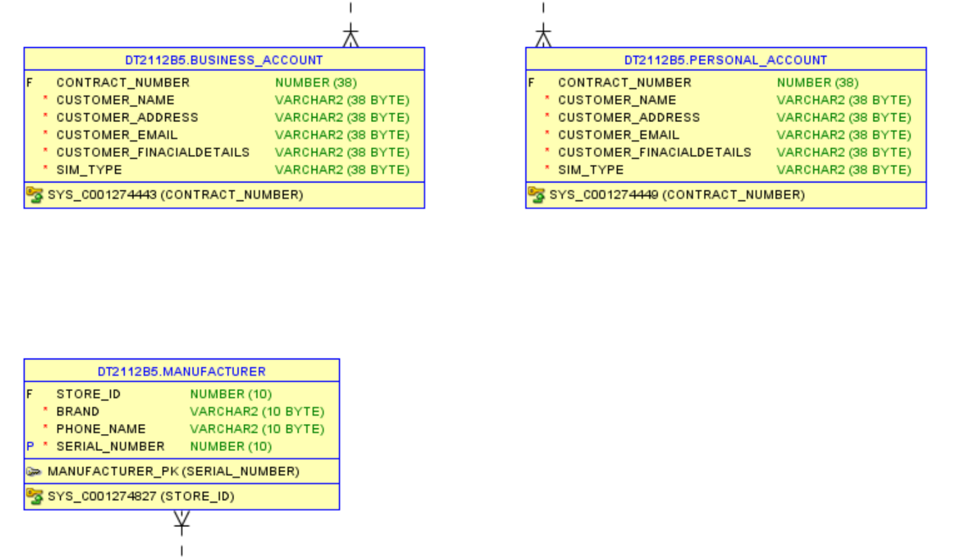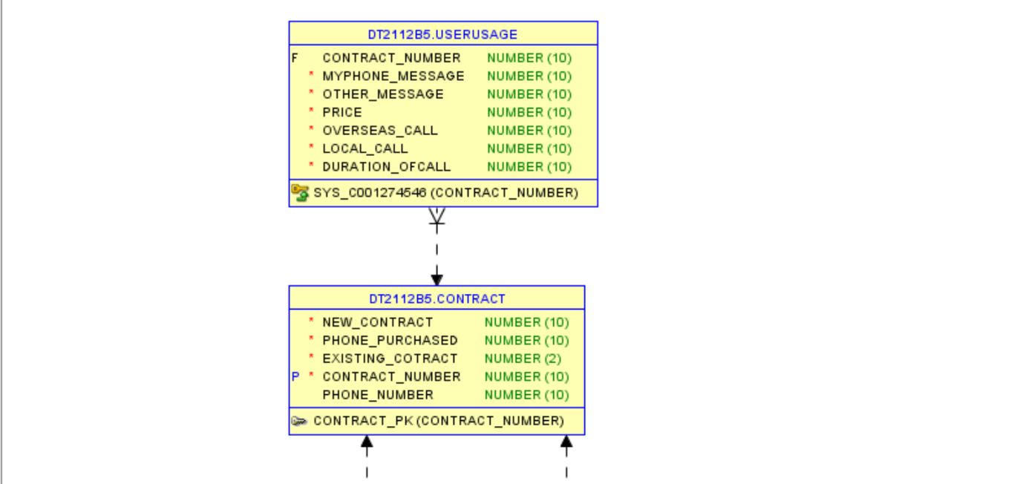**ERD Diagram**